Sukkur IBA University


Data Structure Algorithm

Name: Tariq Mehmood
CMS ID: 023-23-017
Semester: 3rd
Section: E
Submitted by: Sir Riaz Hussain
Lab No: 03

Q1:
public class Task1L5 {
int size = 6;
int arr[] = new int[size];
int rear = -1;
int front = 0;

void isempty() {
if (front > rear) {
System.out.println("Queue is empty");
}
}

void enqueue(int data) {
if (rear < size - 1) {
arr[++rear] = data;
System.out.println(data + " added to queue");
} else {
System.out.println("Queue is Full");
}
}

void Remove() {
if (front > rear) {
isempty();
} else {
int removed = arr[front];
front++;
System.out.println("The First Element Removed: " + removed);
}
}

void getFront() {
if (front > rear) {
isempty();
} else {
System.out.println("Front element is: " + arr[front]);
}
}

int getSize() {
return rear - front + 1;
}

void printALL() {
if (front > rear) {
isempty();
} else {
System.out.print("All elements of Queue: ");
for (int i = front; i <= rear; i++) {
System.out.print(arr[i] + " ");
}
System.out.println();
}
}

public static void main(String[] args) {
Task1L5 obj = new Task1L5();
obj.enqueue(30);
obj.enqueue(43);
obj.enqueue(354);
obj.enqueue(35);
obj.enqueue(54);
obj.enqueue(99);
obj.Remove();
obj.printALL();
obj.getFront();
System.out.println("Current size of the queue: " + obj.getSize());
}
}

Output
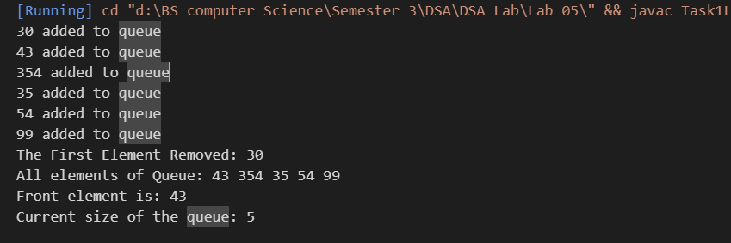

Q2:
class Node {
int value;
Node next;

public Node(int value) {
this.value = value;
this.next = null;
}
}
class Queue {
private Node front, rear;
private int size;

public Queue() {
this.front = this.rear = null;
this.size = 0;
}

public void enqueue(int value) {
Node newNode = new Node(value);
if (this.rear == null) {
this.front = this.rear = newNode;
} else {
this.rear.next = newNode;
this.rear = newNode;
}
size++;
}

public int dequeue() {
if (isEmpty()) {
System.out.println("Queue is empty");
return -1;
}
int value = this.front.value;
this.front = this.front.next;
if (this.front == null) {
this.rear = null;
}
size--;
return value;
}

public int getFront() {
if (isEmpty()) {
System.out.println("Queue is empty");
return -1;
}
return this.front.value;
}

public int getSize() {
return size;
}

public boolean isEmpty() {
return this.front == null;
}

public void printAll() {
if (isEmpty()) {
System.out.println("Queue is empty");
return;
}
Node current = front;
while (current != null) {
System.out.print(current.value + " -> ");
current = current.next;
}
System.out.println("null");
}
}

public class Task2 {
public static void main(String[] args) {
Queue queue = new Queue();
queue.enqueue(10);
queue.enqueue(20);
queue.enqueue(30);
System.out.println("Queue after enqueuing 10, 20, 30:");
queue.printAll();
System.out.println("Front element: " + queue.getFront());
System.out.println("Dequeued element: " + queue.dequeue());
System.out.println("Queue after dequeuing an element:");
queue.printAll();
System.out.println("Queue size: " + queue.getSize());
System.out.println("Is the queue empty? " + queue.isEmpty());
queue.dequeue();
queue.dequeue();
System.out.println("Attempt to dequeue from an empty queue:");
queue.dequeue();
System.out.println("Final state of the queue:");
queue.printAll();
}
}

Output
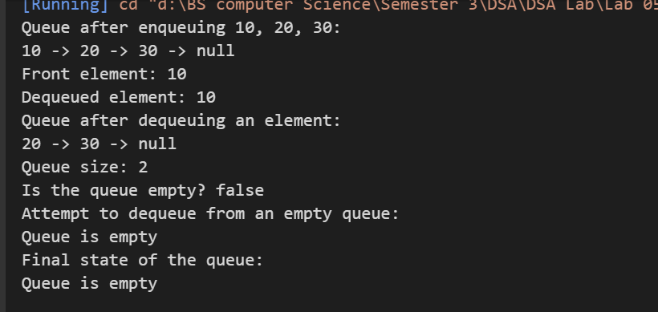
Q3:
public class Task3{
int size=4;
int index=0;
int Stack[]=new int [size];
void push(int element){

if(index<size){
Stack[index++]=element;
System.out.println("The Value is added in Stack "+element);
return;
}
isFull();

}
int pop(){
if(index!=0){
return Stack[--index];
}
else{
System.out.println("Stack is full");
return -1;
}

}
int peek(){
if(index>0){
return Stack[index-1];
}
else{
System.out.println("Stack is empty");
return -1;
}
}
int getSize(){
System.out.print("The size of Stack is : ");
return index;
}
void isEmpty(){
if(index==0){
System.out.println("Stack is empty");
}
}
void isFull(){
if(index==size){
System.out.println("Stack is Full ");
return;
}
}
void printALL(){
System.out.println("All elements of Stack");
for(int i=index-1; i>=0; i--){
System.out.print(Stack[i]+" ");
}
System.out.println();
}

public static void main(String[] args) {
Task3 obj=new Task3();
obj.push(35);
obj.push(36);
obj.push(37);
obj.push(38);
obj.push(39);
obj.push(40);
//obj.push(39);
System.out.println("The Value is poped "+ obj.pop());
System.out.println("The Value is poped "+ obj.pop());
System.out.println("The Value is peeked "+ obj.peek());
obj.printALL();
System.out.println(obj.getSize());
obj.isEmpty();
obj.isFull();
}

}

Output
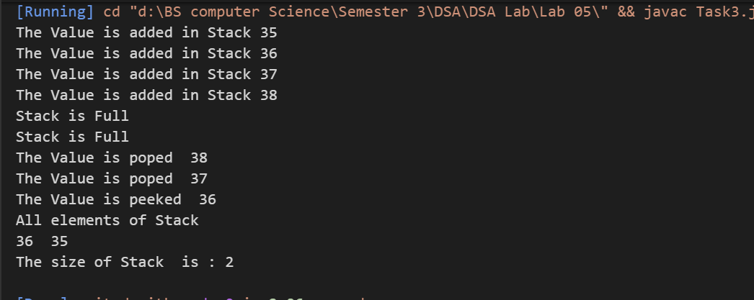
Q4
class Node{
Node next;
int data;
public Node(int data){
this.data=data;
next=null;
}
}
public class Task4{
Node head;
int size;
public void push(int data){
Node newNode=new Node(data);
size++;
if(head==null){
head=newNode;
System.out.println("The value pushed in Stack "+data);
return;
}
Node temp=head;
while (temp.next!=null) {
temp=temp.next;
}
temp.next=newNode;
System.out.println("The value pushed in Stack "+data);
}
public int pop(){
size--;
if(head==null){
System.out.println("Stack is Empty");
}
Node temp=head;
while (temp.next.next!=null) {
temp=temp.next;
}
int a=temp.next.data;
temp.next=null;
return a;
}
public int peek(){
if(head==null){
System.out.println("Linked list is empty");
}
Node temp=head;
while (temp.next!=null) {
temp=temp.next;
}
return temp.data;
}
public int getSize(){
return size;
}
public boolean isEmpty(){
return head==null;
}
void stackReverse(){
Node prev=null;
Node current=head;
Node next=null;
while (current!=null) {
next=current.next;//Store next node
current.next=prev;//Reverse Linked List
prev=current;
current=next;//make new Currrent
}

head=prev;
}
public void printAll(){
if(isEmpty()){
System.out.println("Stack is Empty");
return;
}
Node temp=head;
while (temp!=null) {
System.out.print(temp.data+" ");
temp=temp.next;
}
System.out.println();
}
public static void main(String[] args) {
Task4 stack=new Task4();

stack.push(2);
stack.push(3);
stack.push(4);
stack.push(45);
System.out.println("The value poped "+stack.pop());
System.out.println("The Value peeked "+stack.peek());
System.out.println("The total size of Stack: "+stack.getSize());
System.out.println("The Stack is Empty? : "+stack.isEmpty());
stack.stackReverse();
stack.printAll();

}
}
output
